1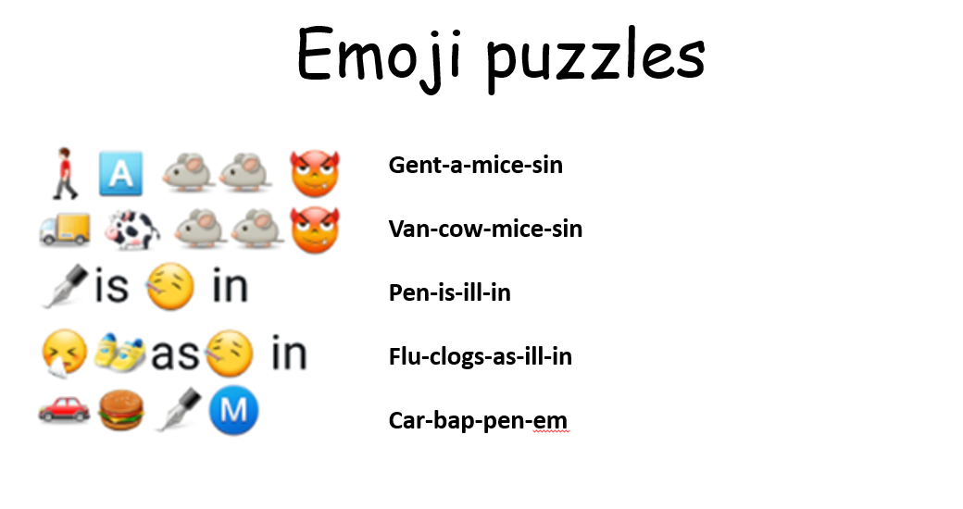
2
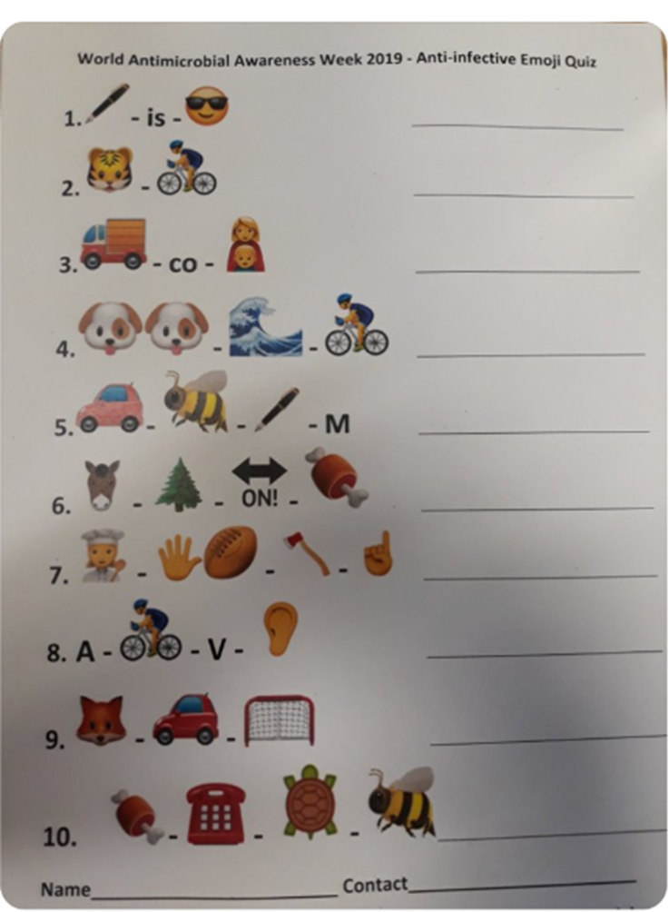
Puzzle number 2 Acknowledgement: @robshorten on Twitter

